Q1.
Using the FOPDT model;
$$P\left(s\right)=K_{p}p^{(\frac{-Ds}{T_{p}S+1})}$$
Where

Kp denotes the system gain,
D denotes the deadtime and
Tp denotes time constant
By employing the first-order Taylor series, we approximated the system as;
P(s) = Kp*(1-D*s)/(Tp*s+1);
By applying the Pi controller, the gain function was developed as follows;
Gc(s) = Kc (1 + 1/$τ_{i}$*s);
Where;
$τ_{i}$denotes the reset time while
Kc denoted the controller gain
The closed-loop characteristic equation was given by the equation below;
1 + Gc(s)*P(s) = 0
This was then simplified to a polynomial shown below;
$$τ_{i}\left({τ_{p}}_{}-KD\right)s^{2}+\left(τ_{i}+K\left(τ_{i}-D\right)\right)s+K=0$$

Part II
$$0.3\left(1.5-2*0.75\right)s^{2}+\left(0.3+2\left(1.5-0.75\right)\right)s+2=0$$
$$0.3\left(0\right)s^{2}+\left(1.8\right)s+2=0$$
$$\left(1.8\right)s+2=0$$
$$s=-1.11$$
State values for Kc
From Routh’s array
S³=0
S²=0
S¹=1.8
S⁰= 2
-1.6<Kc<12.5

Q2. $G\left(s\right)=3/[11s^{2}+5k_{c}s+2.5]$
- Gain is when s=0
$$G\left(0\right)=\frac{3}{\left[11*0^{2}+5k_{c}*0+2.5\right]}=1.2$$

Considering the general form;
Gc(s) = Kc (1 + 1/$τ_{i}$*s);
Considering the polynomial part of the transfer function or gain;

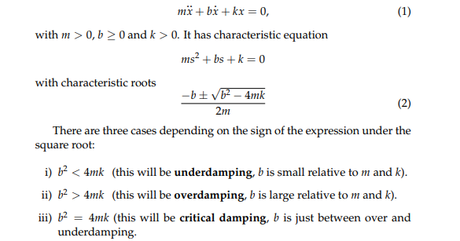
.m=11
.b=5*2.5=12.5
.b²=156.25

4mk=4*11*
.k=2.5
4mk=4*11*2.5=110
From the analysis, it’s clear that the system is overdamped since the second condition is met

Q3. The most sensitive has the smallest acceptable value of $τD$
From visual inspection, the smallest values are
B (2*1), A(3*1),D(3*1),C (4*1)

Finding gains
G(s)=0.75/4s²+7.3s+0.5
When s=0
G=0.75/0.5= 1.5
G(s)=13/5S²+8s+3
when s=0
G= 13/3=4.333
The CSTR situation

